Linux Commands General Format
(1Create a file for writing with comments inside.
(2Start writing comments.
-----------------------------------------------------------------
a- /*Permissions (Mode) Each file has nine characters that represent the permissions on that file. Those are divided into three equal parts: user (u)= user (owner) permissions on the file. group (g) = permissions of members of the group name stamped on the file (except owner). other (o)= all system users other than the group and owner. The main three permissions that may exist on the file are read (r), write (w), and execute (x). These mean different things for files than they do for directories as follows: Read: for files it means the user can view content of file ( using vi, more, cat, …) while for directories it means the user can view content of directory (using ls). Write: for files it means the user can modify the content of the file, but is not allowed to remove it while for directories it means the user can modify the content of the directory (i.e. can create or remove files and subdirectories). Execute: for files it means the user can run the file (scripts or binaries) while for directories it means the user can access the directory ( use cd). To change the mode, a user may use the chmod (change mode) command. This command can specify the new permissions using a relative or absolute method*/.
b- knowledge) File Attributes( Create a file ( vi )and write a comment ( ls –l myfile)
As for the normal file)ls –l) .
c- ) File Attributes(is divided into three sections
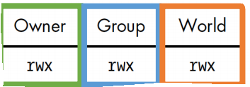

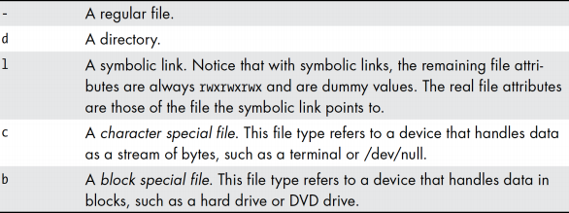
To know the type ) File Attributes(.
d- Chmod using relative method Using this method the user can modify the permissions on a file ( or directory ) relative to the already existing permission as follows: Assume that we start with the

following permissions on a file called myfile r_xrw_r___
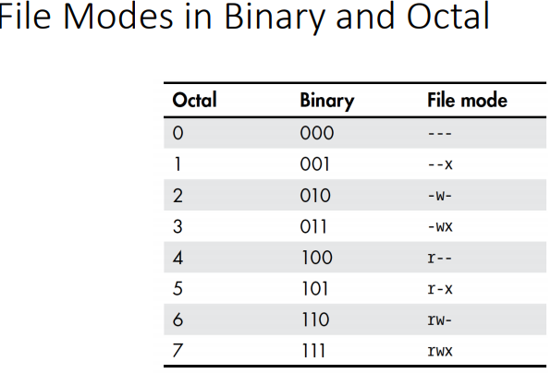
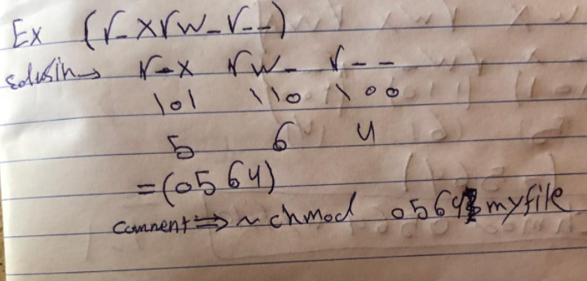
The command: chmod u+w,g-rw,o+ x myfile
/////(-rw----r-x)

Will change the permissions on myfile to rwx____r_x
////(0705)
If we continue with the command: chmod u=rw,g+w myfile
//////(-rw-rw-r--)
The permissions will now become rw___w_r_x
////(0625)
Using the chmod command with absolute mode, change the permissions on both myfile and mydir as follows: rwxr_xrw_ commands= _chmod 0756 myfile__; __ chmod 0756 mydir __.
r__rw____x commands= _ chmod 0461 myfile __; _chmod 0461 mydir__.
___rwx_wx commands=_chmod 0073 myfile_____; _chmod 0073 mydir____.

e- Default Mode
The default permissions that are set on newly created files and directories are set using the umask command. Run the command: umask What number did you get:_0002____.
This number decides the permissions set on newly created files or directories.
Read the manual page for umask ( man 2 umask ) and try to figure out what permissions would you get on files and directories after you run the command: umask 123
Expected permissions on a new file= ______________________________.
Expected permissions on a new directory= ______________________________.

f- Check to see if you understood how umask works by creating a new file and a new directory and checking the set permissions. Did you get it right? _ok__.
What permissions would you expect after the command: umask 625 is executed. Try it to see the results. Did it work?yes = --xr-x-w-_.

g- If you want a newly created directory to have the permissions rwxr___wx
what umask command would you run:
1-vi file1
2-umask 034
3-chmod +rwx file1
4-ls –l file1.
Try it. Did it work? yes___.
To have the following permissions on a newly created file: r__rw___w_
what umask command would you run:_
1-vi file2.txt
2-umask 315
3-chmod +rwx file2.txt
4-ls –l file2.txt_.
Try it. Did it work?_yes__.
What about if you wanted a newly created file to have permissions: rwxr___wx.
What umask command would you run: _
1-umask 034
3-chmod +rwx file2.txt
4-ls –l file2.txt_.
_____.
Try it. Did it work? __yes. Why? ___The file settings have changed____.

h- Since we can modify the mode property of a file we can do more testing to see how links work. Go back and create two files called file1 and file2 and then create a hard link called hlink to file1 and a symbolic link called slink to file2. List the commands you used
- ln –s file1.txt symbolic-hlink
- ln –s file2.txt symbolic-slink
Now try changing the permissions on file1 to rwxrwxr__. Command:__chmod 0774 file1.txt_____
What happened to the permissions on hlink? Why? __ Nothing has changed and remains the same _ Nothing has changed and remains the same__.
Now change the permissions on hlink to rwx______x.
Command:_ chmod 0701 symbolic-hlink ________________________.
What happened to the permissions on file1? Why? _ Changes done ) File Attributes(._Nothing has changed and remains the same ________________.
Now try changing the permissions on file2 to rw_r_xr__. Command: chmod 0654 file2.txt __
What happened to the permissions on slink? Why? Nothing has changed and remains the same _ Nothing has changed and remains the same ______.
Now change the permissions on slink to r__rwxr_x. Command: chmod 0475 symbolic-slink ___.
What happened to the permissions on file2? Why? _ Changes done ) File Attributes(._Nothing has changed and remains the same _.
What happened to the permissions on slink?____ It remained the same ______.

- Ownership and Groups The next file property is the name of the owner of the file. The owner is the only user (other than root) that can modify the properties of a file. The root is the only one that can change a file ownership using the command chown as follows: chown newuser filename Try changing the ownership of any of your files. Did it work?yes___.
- The following file property is the group name on the file. This group name may be modified by the owner if he/she is a member of the new group he/she wants to put on the file. To change the group, a user uses the command chgrp as follows: chgrp newgroup file Try to change a group on any of your files. What happened?____yes__.
j- The next property shows the size (in bytes) of a file. Try creating a file and putting the phrase “how are you” inside then save and quit. What is the size of the file?__12___.
Why? Because every character is about one size.
Change to directory /dev. Command:_1- cd /dev 2- ls -l_____.
Check out the size property on device files. What did you find? • Devices are defined by type, such as 'block' or 'character', and 'major' and 'minor' number. • The major number is used to categorize a device. • The minor number is used to identify a specific device type. • These are the two numbers precede the date in the following.
What are the two numbers that exist instead of the size?
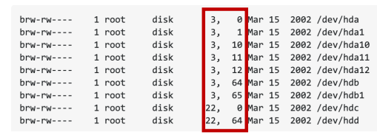
Go back to your home directory. Command:__cd________________.
Go back and display the size of the symbolic link (slink) you created earlier.
Can you figure out how that size was calculated?_ The number of characters in the file name....._9____.
Try creating a new symbolic link and see if you are able to figure out how the size on a symbolic link is set. What did you find? _ The number of characters in the file name ____.

k- Time Stamps A file has several time stamps. The main two are: 1- Last modification time: which is the time the file was last modified and saved. This is the default time displayed by ls –al command.
Last access time: which is the time the file was last accessed or viewed. What ls option is used to display that time. _ls -alu___ (Check the man pages)..
Check the times on file myfile and record them. Now view the file using the more command. What happened to the times? __ Give the time the last time you saved it, and the last time you used it __.
Now open the file myfile, modify it and then save and quit.
What happened to the times now? _ The time changed to it last time and the last time it was saved __.
Another way to display file properties in detail is to use the stat command. Run the stat command on file myfile as follows: stat myfile What information can you see: name file ,link.size,Access,Modify,change________________________________________________
File name A Linux file name can be up to 255 characters long and is made of any characters. A dot has no special meaning in a file name except if it is the first character then the file is a hidden file. Create a hidden file called .hidden. Command:___touch .hidden_______.
Try to list your files using the command ls. Can you see .hidden? _no_______.
Now try to list the files using the command ls with the –a (all) option? Can you see it now?__yes________________.
For more information on the output, you can read the man pages on the stat.
3) Exit to save all lab workers

